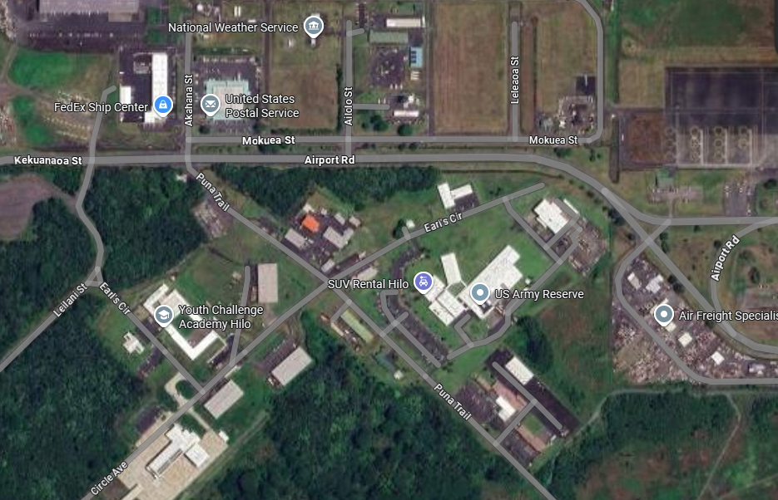
Keaukaha Military Reserve (KMR), Building 621, room 121, Environmental Office location as marked on map. When entering, all contractors/visitors must check in at the gate entrance before proceeding to the project location. Please contact me if you are interested in attending the project walk through @ POC: Alvin Sniffen | (808) 590-0783 | State DoD FMO Office
Hilo, Hawaii
NEW MINI SPLIT AC
INSTALLATION EQUIPMENT FOR KMR ARMORY

